Active Parolee Clients Report
- From the Clinician’s Home Page Systems button, follow the path to Client Roster Report:
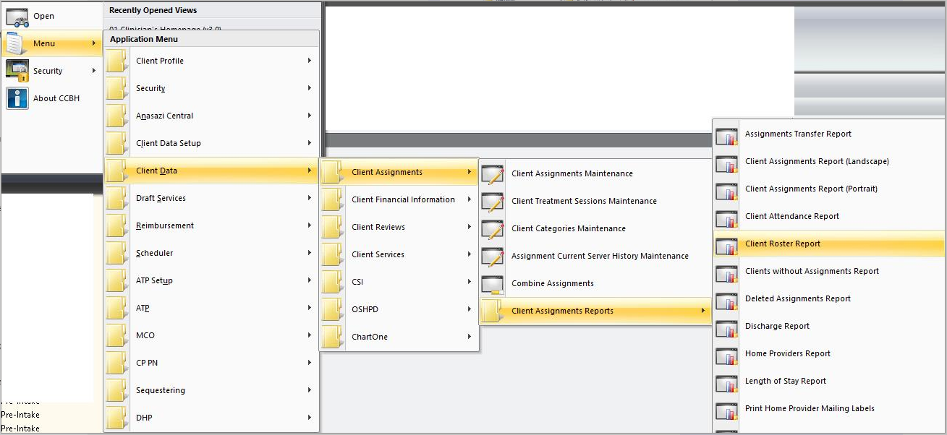
- Select the Load button to open the templates view:

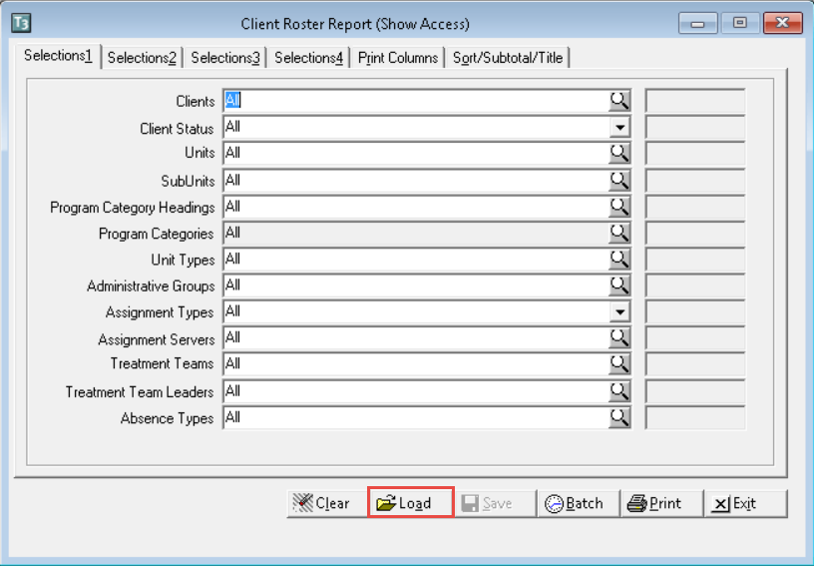

- Select Active Parolee Clients then select Load button.

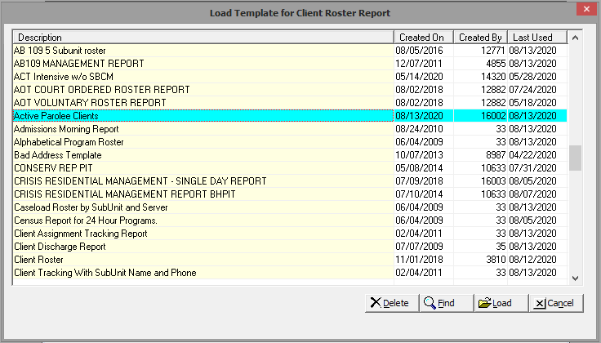
- Selection 1- Change Units to your desired program(s).

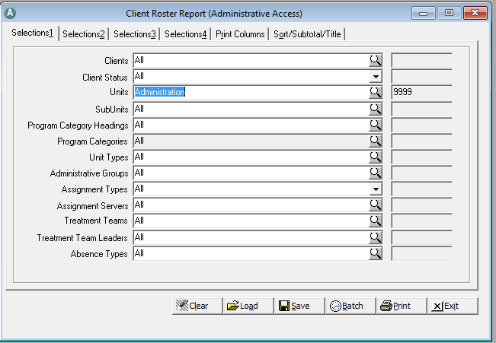

- Selection 2- No action required. Open assignments is already selected.
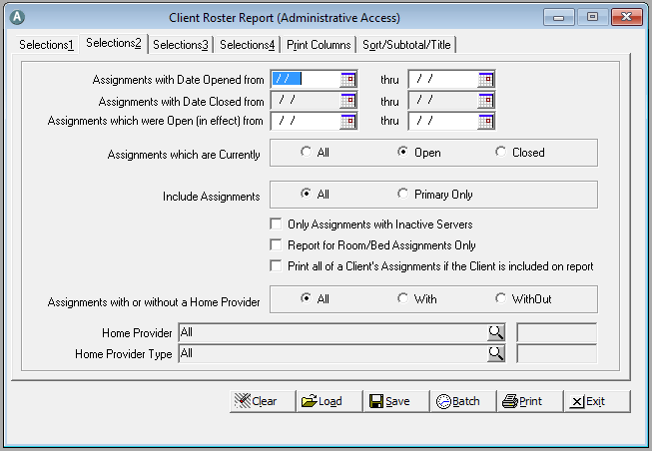
- Selection 3- No action required.
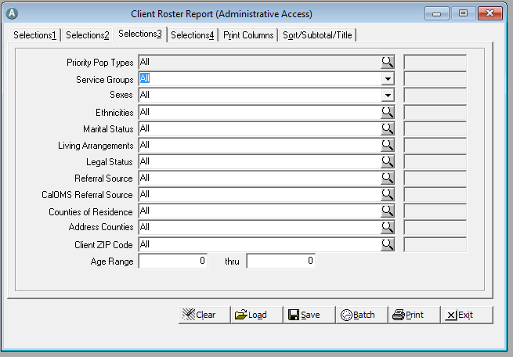
- Selection 4- No action required. Parolee Client Category is already selected.
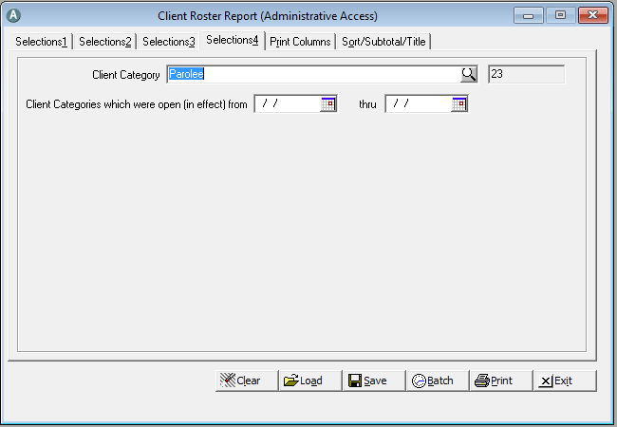
- Print Columns- No action required.
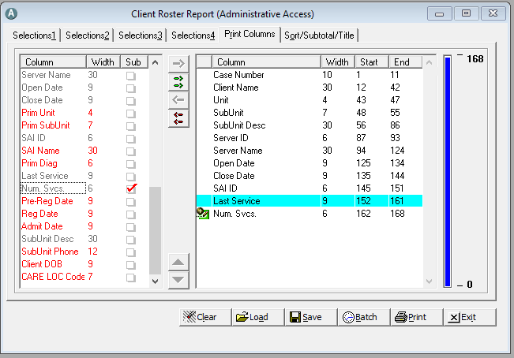
- Sort/Subtotal/Title- Select Print.
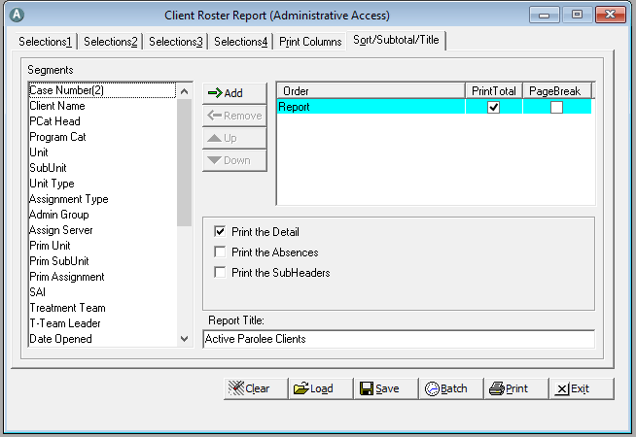

- Print Destination window will appear. Select your desired print type.
